**Notify Leave App Overview**

As part of multiple efforts in improving/automating our Operations in our DU, we’ve moved to a new Application for Leave Notification & Leave Data Mgmt starting **October 3rd 2022.**

To notify any type of leave (Planned, Unplanned, Sick or just ANY type–except for public holiday), **please log on to your respective DU’s “Notify Leave” App** and notify via the same. This is a custom-built app for our DU that's serving as the single system of record for Leave Management.   
  
***Log on to “Notify Leave” app – via any of the below 2 methods:***

*Method 1:* *(Recommended)*

Install “Power apps” app from your play store in Smartphone. Once the app is installed, look for your respective DU’s leave app (As per app name below) and launch the app.

DU01 Leave app name: ***DU01 Notify Leave***

DU08 Leave app name: ***DU08 Notify Leave***   
  
*Method 2 :*  
Bookmark this URL in Microsoft Edge browser in your Smartphone and launch.   
Note : Smartphone should be registered in Intune, a common pre-requisite for accessing any Accenture or Microsoft sites, using Accenture email id.

DU08 URL : <https://go.accenture.com/du08notifyleave>   
DU01 URL : <https://go.accenture.com/notifyleave>

**Leave Notification Process -**   
  
**What’s expected from You?**

1. **You’re expected to MANDATORILY notify your Leave via this App without any exceptions**. In case you're not able to notify your leave due to emergency, kindly request your supervisor or your DU’s DAT Team to notify on your behalf.
   * **Primary Mode of Leave Notification:** Any type of leave – planned or unplanned or illness, short, or long – this App MUST be the First & Primary source of notifying your leave.
   * Sending SMS, WhatsApp, email in Acc, etc. to your peers/Supervisor will be optional and up to your preference, notifying via App is a mandate to everyone.
2. **Unplanned/Sick Leave Notification:**
   * Any notification of **unplanned leave must be done prior to 1 pm IST** via the App, to avoid getting flagged as Late notification by the App.
   * **Unplanned Leave Threshold:** Please limit your unplanned leaves in a Fiscal Year (Sep 1 - Aug 31) to <=15. This includes Sick/Wellness leaves you're entitled to, as per Leave policy. This rigor is required for better Financials Forecasting, fair distribution of workload among the Team and to encourage better planning of leaves.
   * **Disruption**: This leave type can be chosen whenever an Employee couldn’t login to work due to any type of unforeseeable disruption related to technical, infra issues or external events such as cyclone, rain etc. In these cases, the MyTe charge codes for the resource’s leave balance (or any other approved WBS, if communicated) should be used.
3. **Required Leave Notice for Planned Leave:**
   * Any leave notified **less than 4 weeks from *Leave Start Date*** will be counted as "**Unplanned Leave**" by the App, disregarding the leave type chosen when notifying the leave, in app.
   * Availing Floating Holidays & Compensatory off also require adherence to the above notification window, since they are predictable and can be planned.
   * Bereavement Leaves, Long Medical Leaves, Disruption and Client Furlough are not counted as Unplanned leaves.
4. **Planned Leave Data:**
   * Planned leaves that you are yet to avail, must be entered by you in the App (Even if you notified via email to your Supervisor already, for any future-dated leaves)
5. **Client Furlough**: If Bank has asked to take “mandatory furlough” time away, you are expected to log the dates you give to Bank Manager for the Furlough requirement in this Leave app, choosing the leave type as "**Client Furlough**".

* **NOTE:** This Leave Type should be used only for the additional leaves being planned to meet Client mandatory ask, not for your personal planned leaves for the upcoming months.

1. **Long Medical Leave:** Any leave taken due to hospitalization of self or a dependent for more than two consecutive days will be categorized as Long Medical Leave in our Leave App.

* There is no corresponding MyTe charge code for this leave type, as it is solely for internal tracking purposes. This leave will not be considered for calculating Unplanned Leaves.

1. **Secondary Caregiver Leave:** Secondary caregivers (for a newborn or adopted child) are entitled to 15 days of paid leave, which can be taken consecutively or in segments of at least 3 days each.

* Upon presenting adequate medical proof, this leave can commence from the date of birth of the child or the date of adoption but must be utilized within six months of the event
* This leave applies only to secondary caregivers and should not be confused with any other caregiver leave provided

1. **Leave Cancellation**: If you do not intend to avail a planned or notified leave by the start date, please update the "Leave status" field to 'Cancelled'.
2. **Leave Date(s) Change:** To postpone/extend a leave that you had already added in the app–you can make required changes using the edit option, which will go for a review.
3. **Automated Daily Leave Summary:** Everyday afternoon in Accenture email, **"DU - On Leave Today - Summary ''** will be auto-published with the leaves notified for the day. You can look out and report to POCs noted below, if at all there are any discrepancies for your name.
4. **MOST IMPORTANT** – This App introduction does NOT change the process you follow today to additionally email / notify your leave to your Clients. That needs to be continued, as is being done today.

**Daily Availability Tracking (DAT) POCs**

**DU08:** DU08 DAT Team can be reached at [DU08-DAT@accenture.com](mailto:DU08-DAT@accenture.com) for any queries/issues

**DU01:** DU01 DAT Team can be reached at [DU01-DAT@accenture.com](mailto:DU01-DAT@accenture.com) for any queries/issues

**Why are we doing this?**

Central place of reference for anyone across DU to know anyone’s leave info, at any time

* + Team members can notify leave via one channel consistently across DU & have a record of their own leaves, for later reference when filling timesheets
  + Leads/Supervisors have a single point reference to know members on leave, for the day or when reviewing timesheets/financials reports, etc.
  + Easier review for POCs to now review just outlier records and reduced efforts in tracking or Leave data mgmt..
  + Enables us with cleaner, quality & reliable leave data to generate metrics and trends around leaves, especially unplanned leaves

**Additional Info, for your awareness :**

* DAT POCs will be performing review of all leave data weekly once and discrepancies will be published.
* Leave metrics will be available in this real time Dashboard ( <https://go.accenture.com/timeoffsummary> ) – to derive insights on Leave management discipline, forecasting and due notice to keep unplanned leaves under our threshold/limit (Please refer **#2** above in ‘**What’s expected from you?**’ section). This is one leaderboard where you should not be appearing in any of the Top rank spots 😊.

**Steps to view added leave plans & notify new leave plans: -**

1. Launch the Notify Leave app.
2. Tap on the mail icon. (To view added plans, kindly wait till the app load is complete)

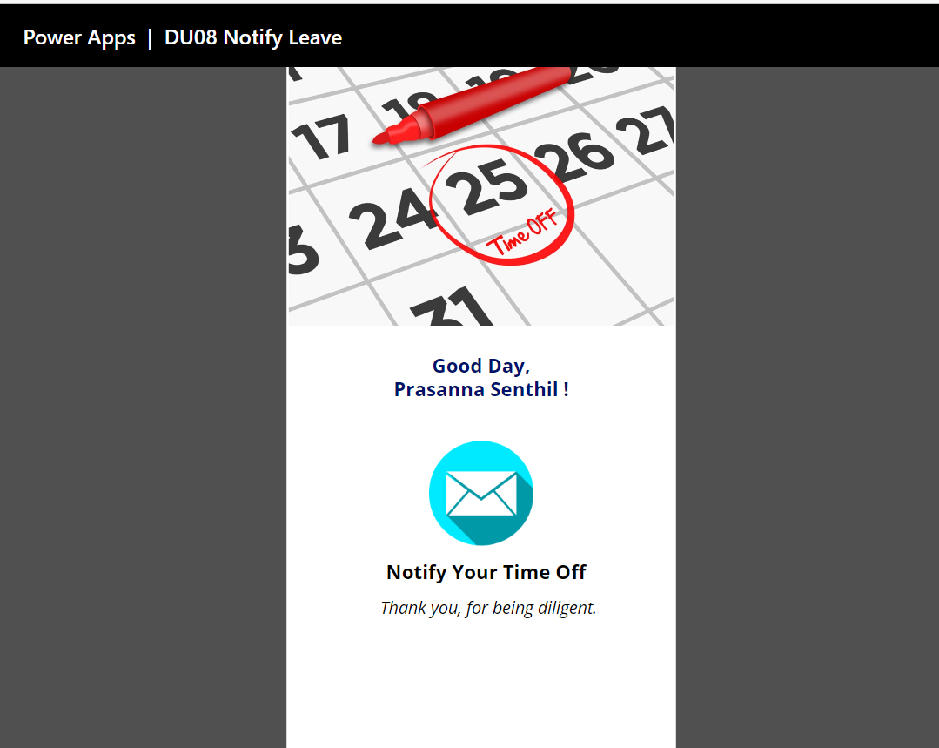

1. Use filters to view previously notified leave plans. You can filter the leaves by
   1. Employee’s email
   2. Project
      1. DU08 Project -> FCCAT, DB521, 1171, 1282, DCRS, Yet to Onboard & PMO
      2. DU01 Project -> 1136, 1286, Yet to Onboard & PMO
      3. Hardlocked resources that are yet to be onboarded to our project should select '**Yet to Onboard**' in ***Project/SOW*** & ***Sub-LOB/Team*** fields while submitting their leave plans.
   3. Leave Status (Availed, Planned, Cancelled)
   4. Leave Start Date

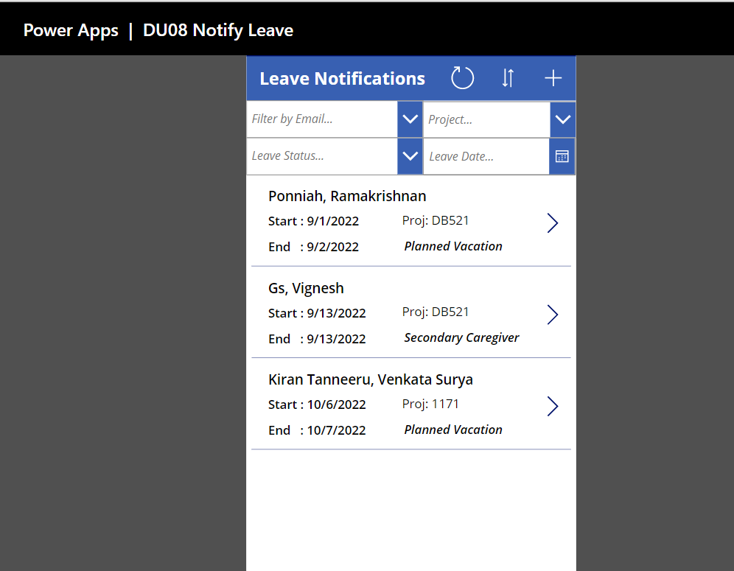

1. Tap on your name to view complete details of your leave. (You can also view leave plans of your teammates)

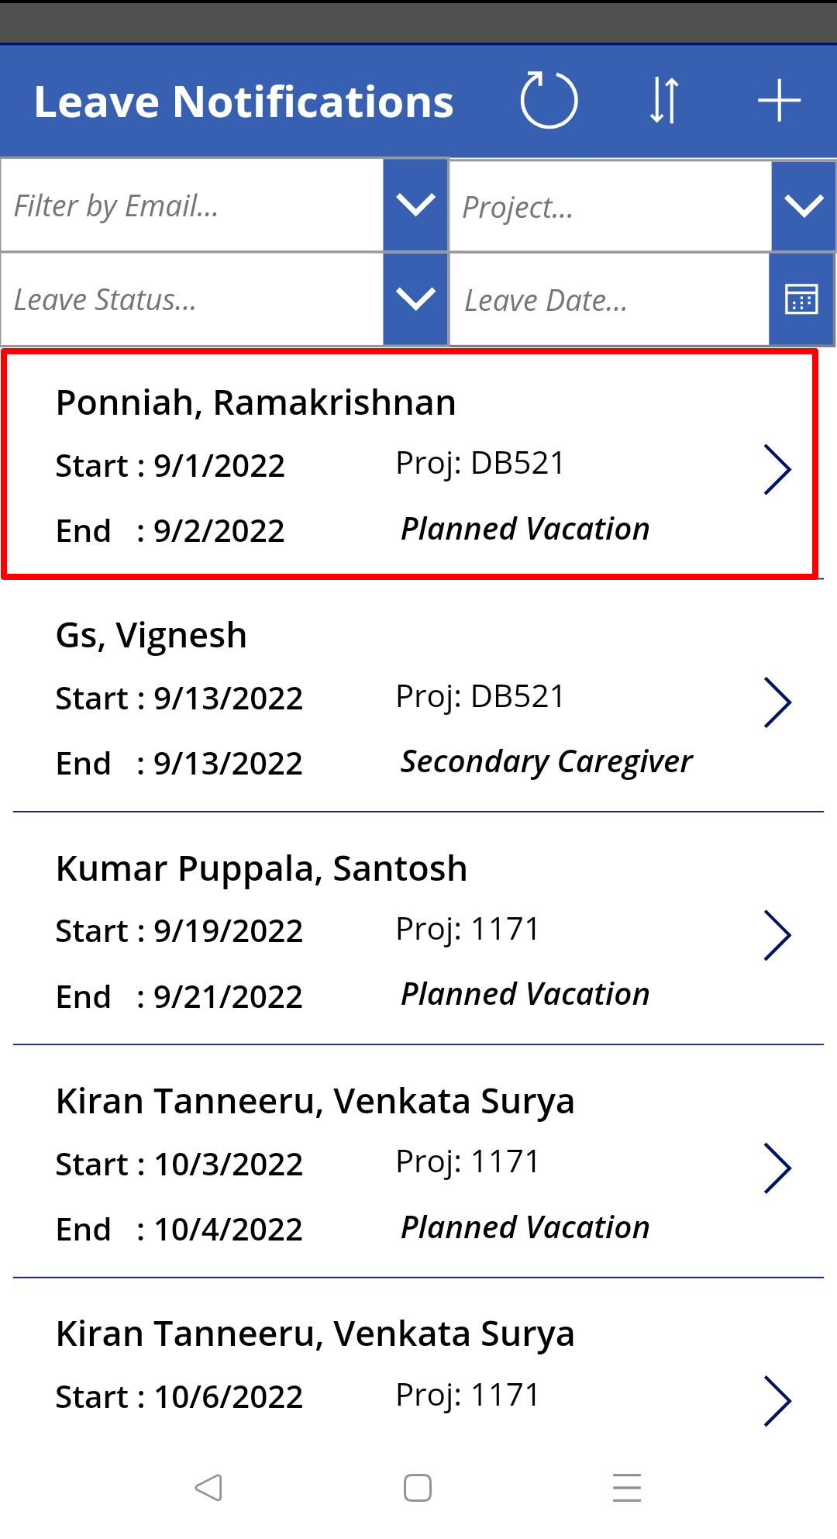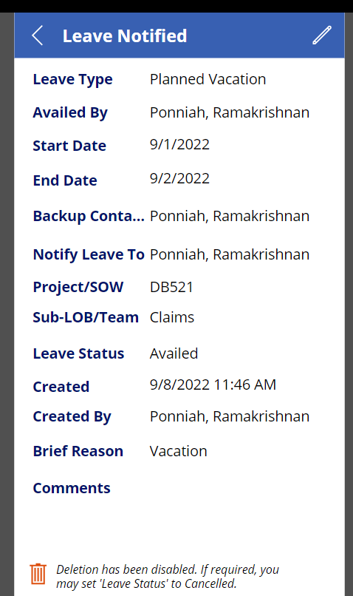

1. To add a new leave plan, tap on +

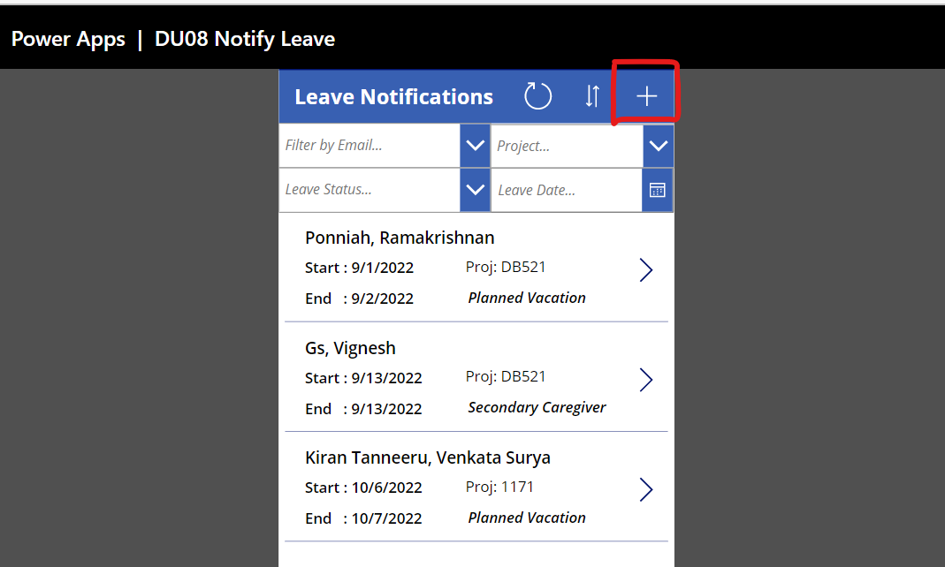

1. Enter all the required leave details

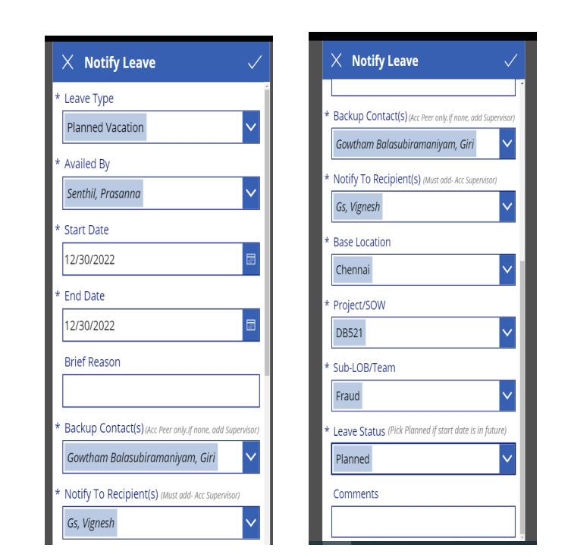

Leave type (Select the appropriate leave type. Planned Vacation should be notified at least 4 weeks before Leave start date)

* Sick Off
* Planned Vacation
* Unplanned Leave
* Floating Holiday
* Compensatory Off
* Bereavement
* Vaccination
* Long Medical Leave
* Maternity Leave
* Secondary Caregiver Leave
* LOA
* Disruption
* Client Furlough

1. Availed By (Enter Accenture Email ID of the resource who’s availing the leave)
2. Start date (Start date of the leave)
3. End date (End date of the leave)
4. Brief reason (Text box to enter reason. This is an optional field)
5. Backup contacts (Enter Email ID of the Accenture-backup resource. If there’s no Accenture backup, please enter supervisor’s Accenture Email ID)
6. Notify to Recipient(s) (Mandatory: Accenture Email ID of the resource’s supervisor. If any additional teammates need to be notified, you may add them)
7. Base Location (Select your official base location from the available options)

* Bengaluru
* Chennai
* Hyderabad
* Ahmedabad
* Coimbatore
* Gurugram
* Kolkata
* Mumbai
* New Delhi
* Noida
* Pune
* Other

1. Project/SOW (under which you’re aligned)  
     
   DU08 Projects:

* DB521
* FCCAT
* 1171
* 1282
* DCRS
* Yet to Onboard
* PMO

DU08 Sub-LOB/Team (Select your Team)

* Claims
* Credit Assistance
* Fraud
* DCRS
* OT / LSST
* Yet to Onboard

DU01 Projects:

* 1136
* 1286
* Yet to Onboard
* PMO

DU01 Sub-LOB/Team (Select your Team)

* FCT QA
* EPT QA
* Mobile QA
* FCT DEV
* ECVT QA
* EPT DEV
* Mobile DEV
* DPT QA
* DPT DEV
* ECVT DEV
* PMO
* Yet to Onboard

1. Leave Status

* Planned
* Availed
* Cancelled
* If you are entering a leave with a start date in future, please set the Leave Status to ‘Planned.’
* Capability to delete an added leave record is restricted. To cancel or modify an

existing leave record, follow the steps given in the next section.

1. Comments (Add comments if needed. This is an optional field)

7. Tap on after entering all the required details. Your leave plan will be saved.

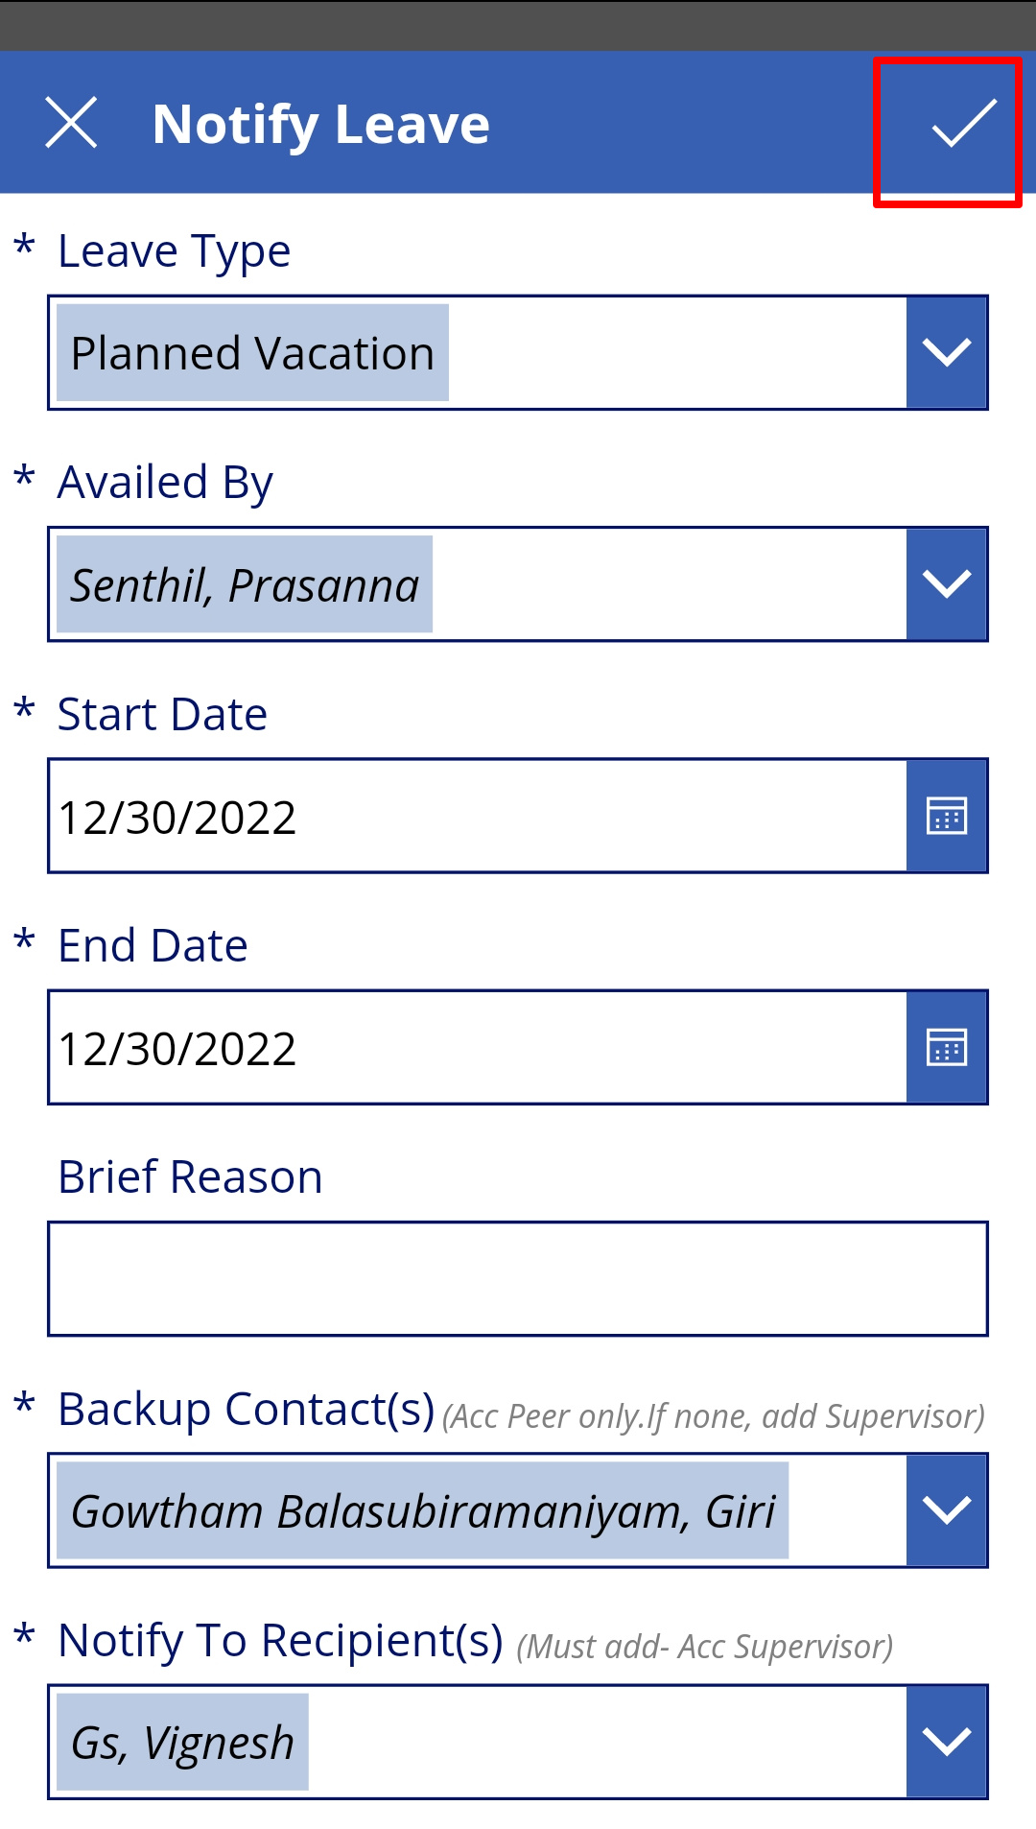

**Steps to modify added leave plans:-**

1. Select the leave record that needs to be modified and tap on 

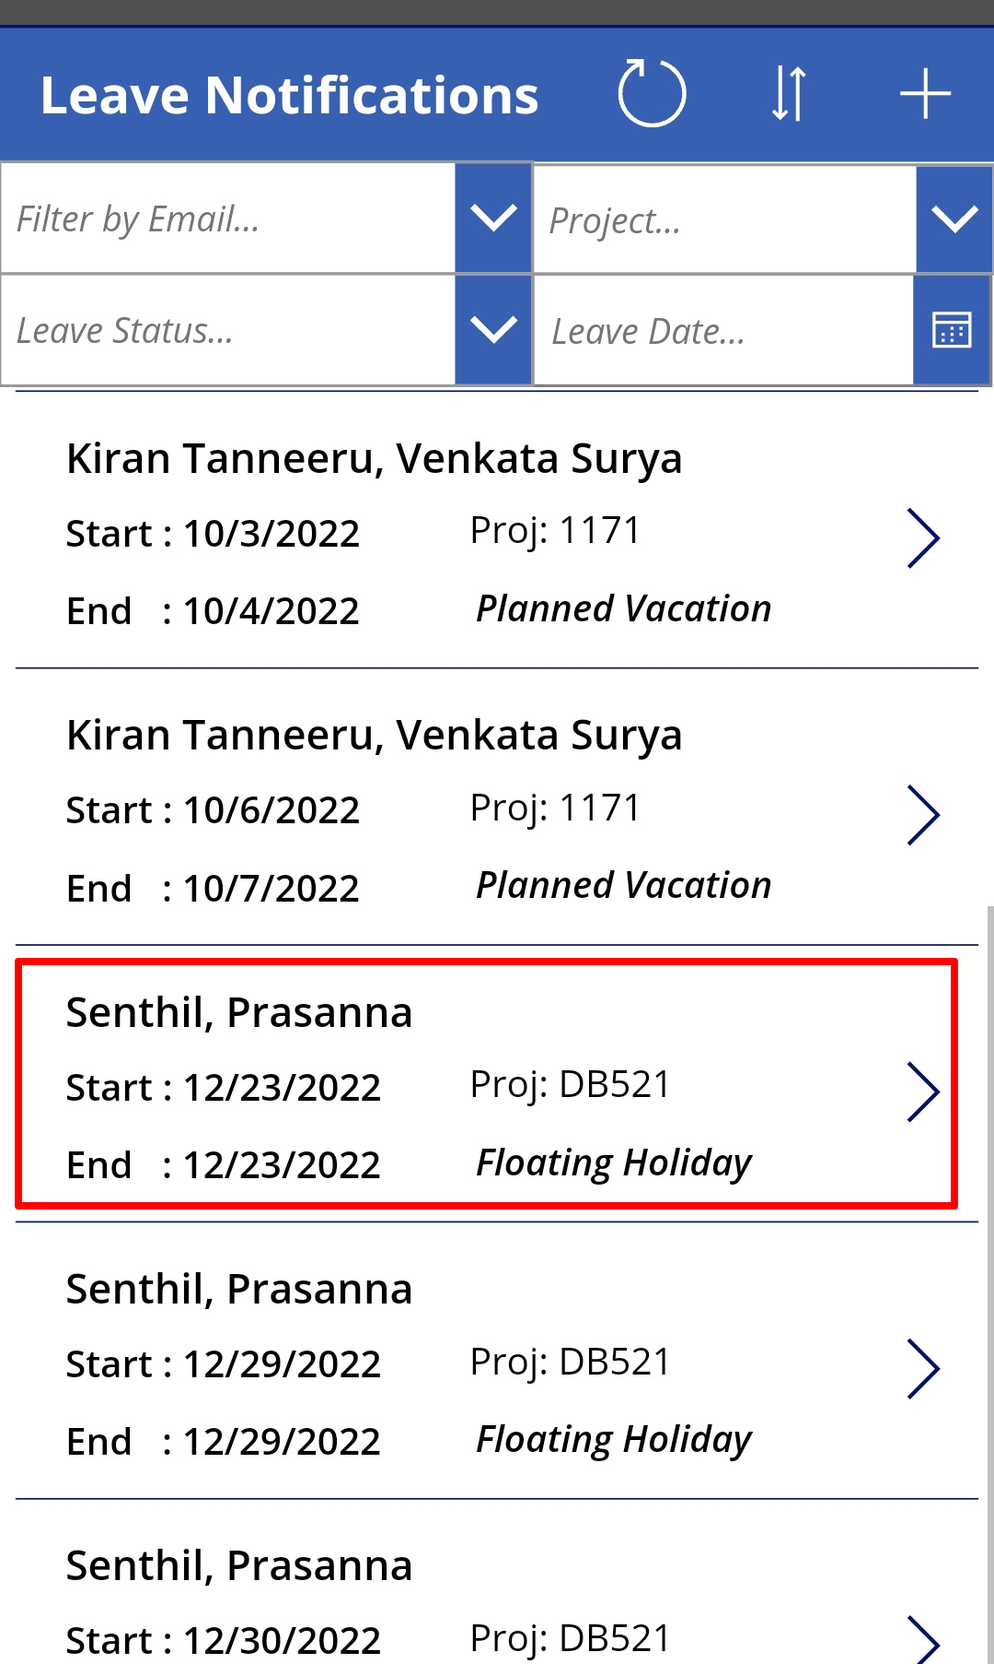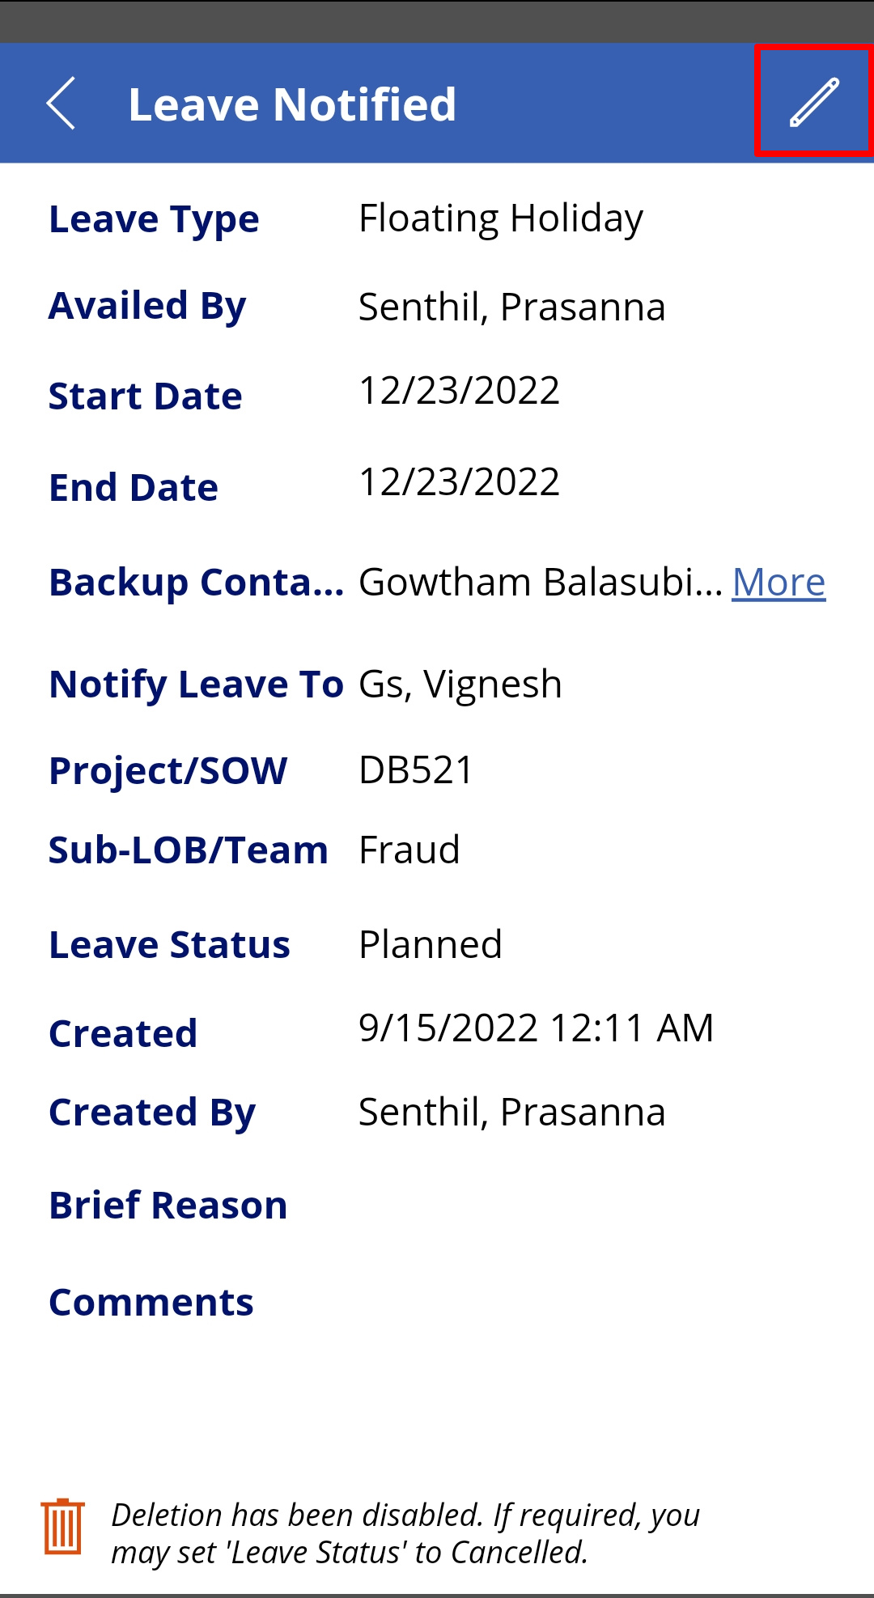

1. Tap on any details that you want to be modified (Below are the screens to edit date)

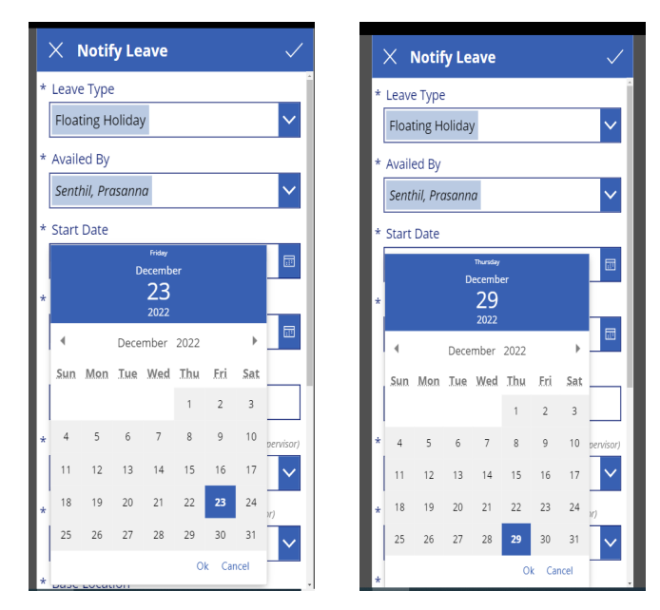

1. Tap on after updating and the changes will be saved

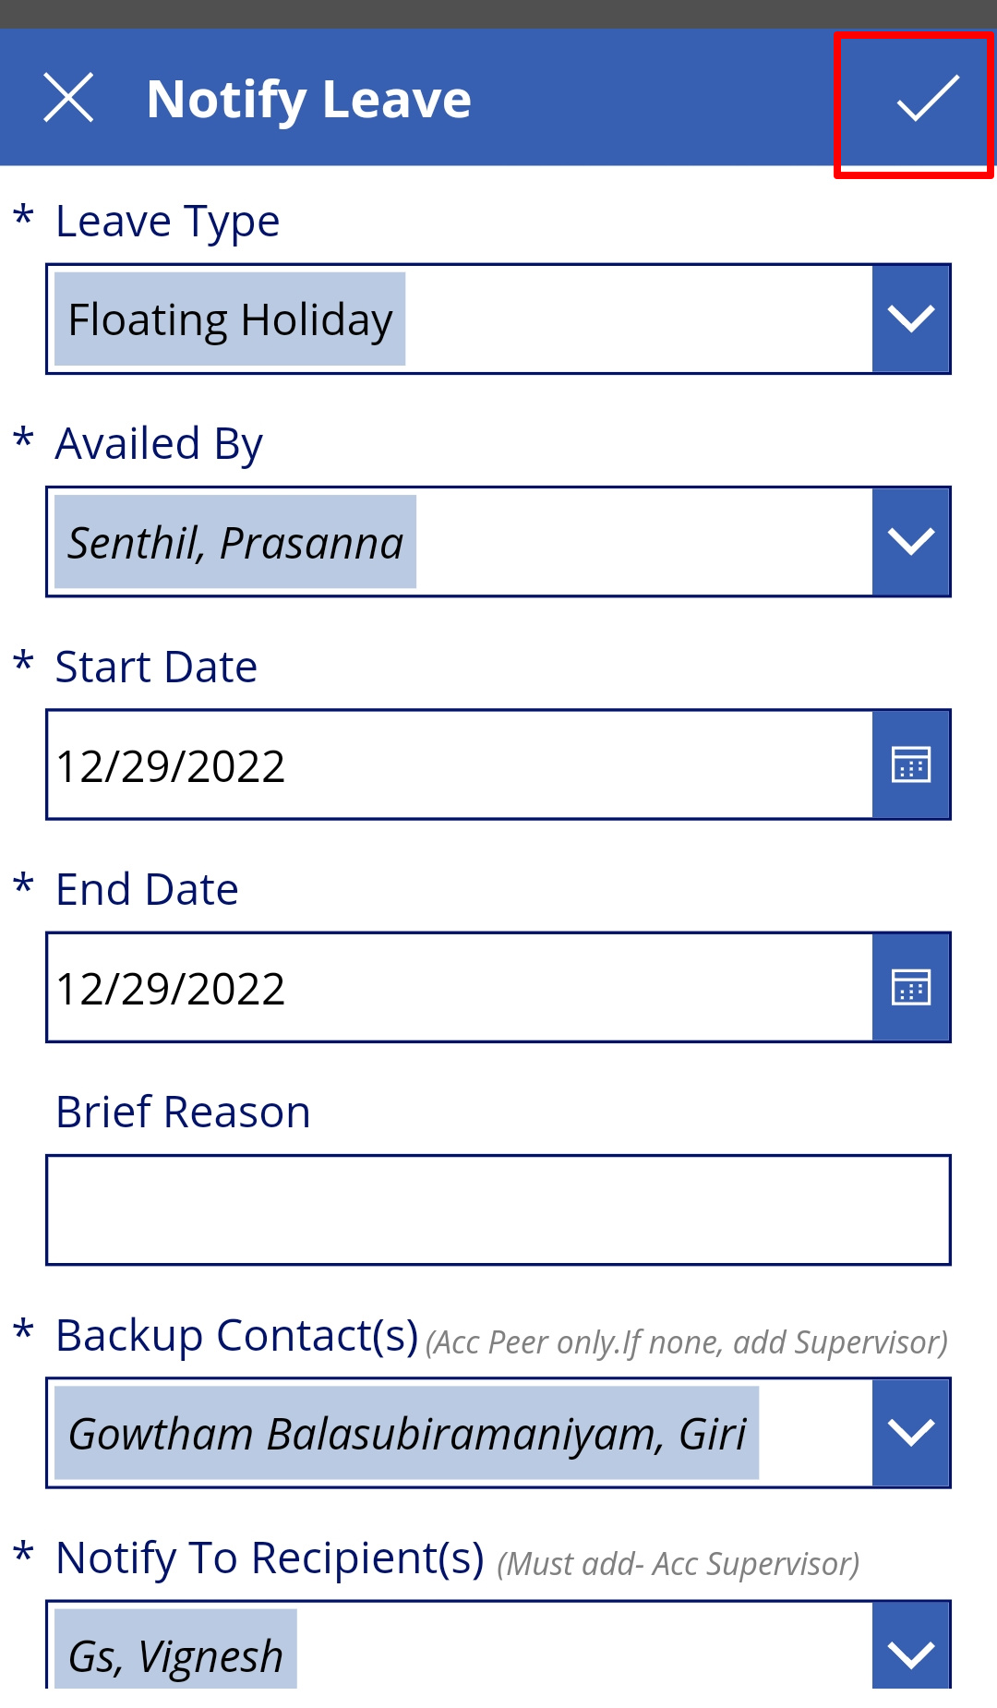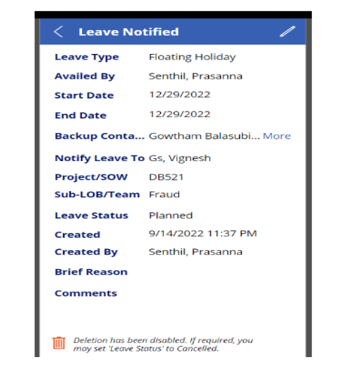

**Steps to Cancel added leave plans:-**

1. Open the leave record to be cancelled and tap on 

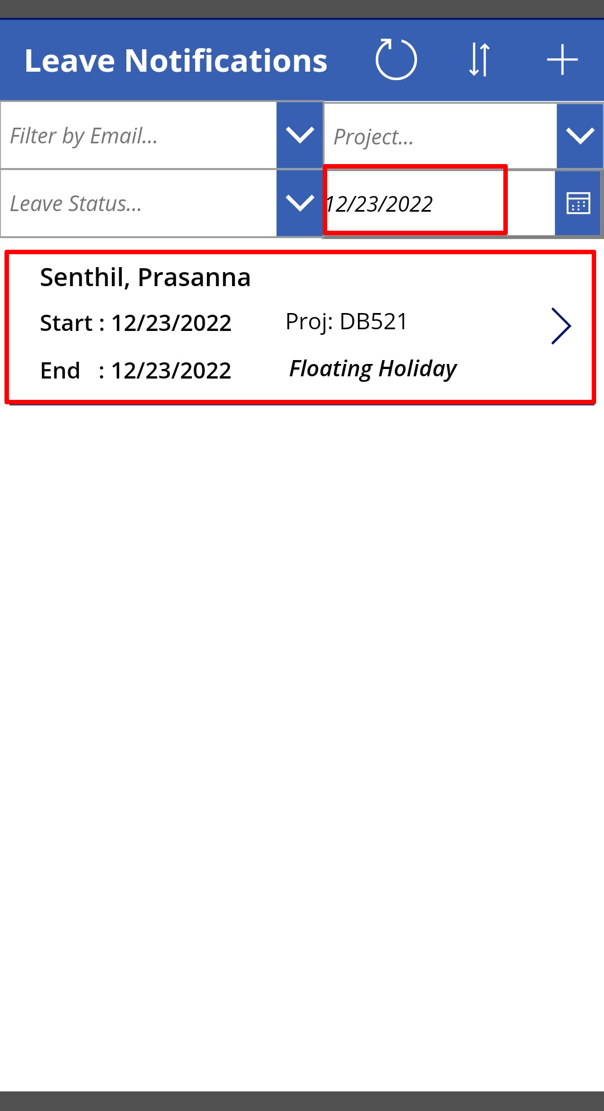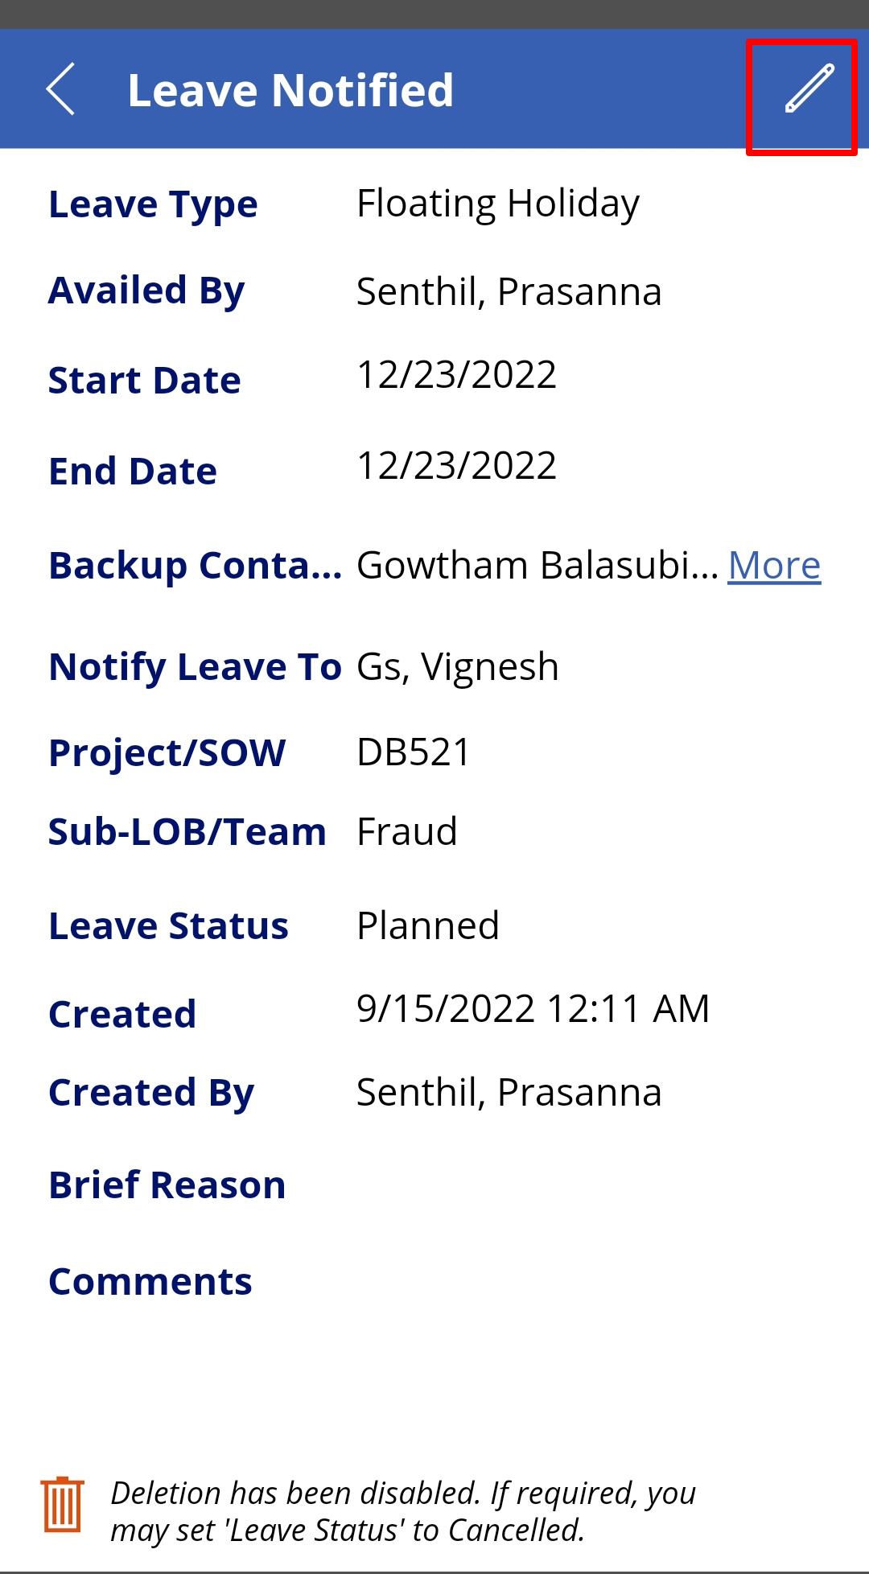

1. Select the ***Leave Status*** field, change the value to ‘Cancelled’ and tap on . Your leave plan will be cancelled.

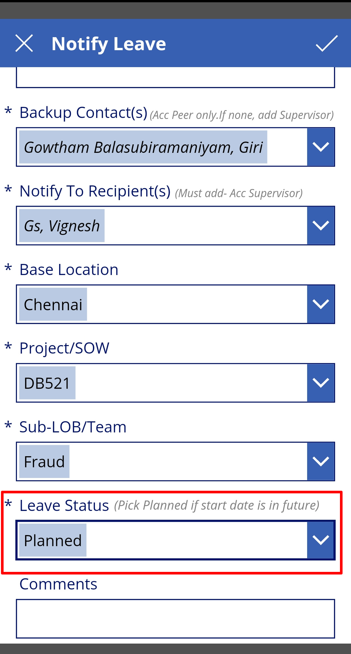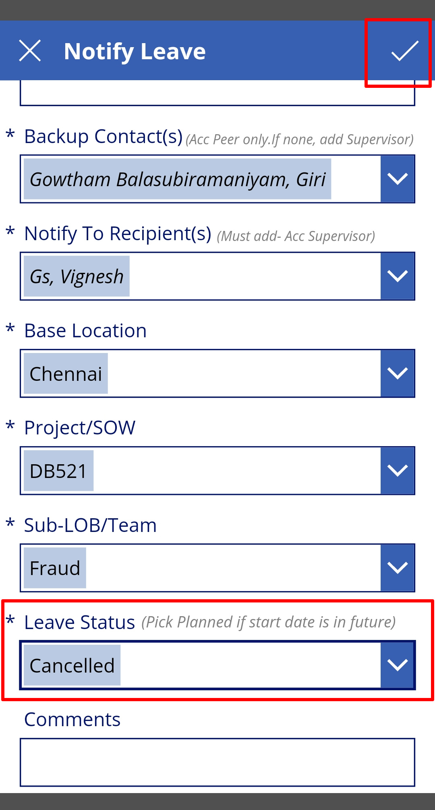

**NOTE:** If there are any issues in the app preventing your leave entry, please reach out to your supervisor or your DU’s DAT Team DG.